
DEPARTMENT OF INFORMATION AND COMMUNICATION TECHNOLOGY
PROG101: PRINCIPLES OF PROGRAMMING LOGIC AND DESIGN
CASE STUDY
Hospitals in Sierra Leone
A Patient Registration, Triage and Queue Management System for Public Hospitals

Title : Designing Logical Solution for Sierra Leone community challenge
Issue Date : Week 2, 2026
Due Date : Week 6, 2026
Lecturer/Examiner : Mr. James Kanga
Name of Student : Chernor Ibrahim Barrie
Student ID No. : 905006582
Class : BBIT1101F
Semester/Year : 1/1
Academic Honesty Policy Statement
I, Chernor Ibrahim Barrie, hereby attest that the contents of this attachment are my own work. Referenced works, articles, art, programs, papers or parts thereof are acknowledged at the end of this paper. This includes data excerpted from CD-ROMs, the Internet, other private networks, and other people’s disk of the computer system.
Student’s Signature: ______________________ Date: ________________
LECTURER’S COMMENTS/GRADE: | For office use only upon receive  Remark: ________________________  DATE: ___________________________  TIME: ___________________________  RECEIVER’S NAME: _______________

Table of Contents
1. Rationale 3
1.1 Problem Description 3
1.2 Background 3
1.3 Community Impact 3
1.4 Proposed Solution 4
1.5 Computational Thinking Process 4
1.6 Algorithm Design 4
1.7 SDG Alignment 4
1.8 Open Source Justification 5
1.9 Digital Public Goods Justification 5
2. Algorithm 6
2.1 Constants, Variables and Data Types 6
2.2 Input, Processing and Output 6
2.3 Triage Scoring Rules 7
2.4 Boolean Logic Used 7
2.5 Step-by-Step Algorithms 7
3. Pseudocode 9
3.1 Constants, Data Structure and Global Variables 9
3.2 Main Program 9
3.3 Utility Functions 10
3.4 Registration Module 10
3.5 Triage Module 11
3.6 Queue Management 12
3.7 Consultation and Reporting 13
4. Flowcharts 15
4.1 Main Program Flowchart 15
4.2 Registration Module Flowchart 16
4.3 Triage Module Flowchart 17
4.4 Queue and Consultation Flowchart 18
4.5 Long-Wait Escalation Flowchart 19
5. Functional Modules 20
6. Expected Outputs 21
6.1 Sample Patients and Triage Results 21
6.2 Sample Program Output 21
6.3 Test Scenarios 22
7. GitHub Evidence 23
7.1 Git Commit History 23
7.2 README.md and Repository Screenshots 24
8. References 25

1. Rationale

1.1 Problem Description
Many public hospitals in Sierra Leone receive far more patients each day than they have doctors, nurses and consultation rooms for. Patients arrive early, are registered on paper and then wait in one long line that is mostly served on a first-come, first-served basis. A woman in labour, a child with convulsions and a man with a mild cough can all stand in the same line. Staff have no quick and consistent way to decide who must be seen first, paper records are easily lost or duplicated, and nobody can measure how long patients really wait.
This assignment designs the logic of a solution called HospiQueue SL. No source code is written; the design is expressed through algorithms, pseudocode, flowcharts and modular design.
Problem analysis | Description
The community problem | Overcrowded hospital reception and outpatient areas with paper-based registration and no fair, consistent way to decide who is seen first.
Who is affected | Patients and caretakers (especially pregnant women, children under five, elderly people and people who travel long distances), nurses, doctors and hospital managers.
Why the problem exists | Few health workers compared with demand, limited funding and equipment, paper records, no shared triage rules, unreliable electricity and internet, and no data on waiting times to guide planning.
How the solution addresses it | Each patient is registered once, urgency is scored from vital signs using clear rules, patients are served RED, then YELLOW, then GREEN, long waiters are promoted automatically, and daily statistics are reported.

1.2 Background
Sierra Leone has worked to rebuild and strengthen its health system since the 2014 to 2016 Ebola outbreak exposed its weaknesses. The Free Healthcare Initiative, introduced in 2010, removed user fees for pregnant and breastfeeding women and children under five, with the aim of increasing their use of services (Free health care for under-fives, expectant and recent mothers?, n.d.). Greater demand on a small workforce (WHO, n.d.) makes the order in which patients are seen a matter of life and death.
The country's National Digital Health Strategy 2018 to 2023 recognizes digital tools as a way to improve health services and information (Ministry of Health and Sanitation, 2018). Open platforms such as DHIS2 are already used for national health reporting. However, registration and triage at the hospital entrance is often still handled by hand in many facilities, and this is the gap that HospiQueue SL addresses. The red, yellow and green priority levels are inspired by emergency triage approaches such as the WHO Emergency Triage Assessment and Treatment (ETAT) guidelines (WHO, 2016).

1.3 Community Impact
- Problem being solved: dangerous delays for urgent cases, unfair queues, lost records and no waiting-time data.
- Expected impact: emergencies are identified and seen first, waiting becomes fairer and measurable, staff work with clear rules, and managers get daily numbers for planning.
- Beneficiaries: patients and caretakers (especially mothers, children and the elderly), nurses and doctors, hospital managers and Ministry of Health planners.
- Long-term sustainability: open-source licence, low-cost hardware, offline-first design and local developers and students who can maintain it.

1.4 Proposed Solution
HospiQueue SL is a logical design for a system placed at the hospital entrance and outpatient department. It has five modules: registration, triage, priority queue, consultation outcome and reporting. The design assumes low-cost computers or tablets and intermittent power and internet, so every step works offline and data is saved locally.
The triage scoring thresholds in this document are illustrative values chosen for a learning exercise. In a real hospital, doctors and nurses would set and approve them, and staff would always be able to override the system.

1.5 Computational Thinking Process
Pillar | Application in HospiQueue SL
Decomposition | A hospital visit is broken into five smaller problems (register, triage, queue, consult, report). Each becomes a module that can be designed and tested on its own.
Pattern recognition | Every patient follows the same path: arrive, register, triage, wait, consult, and leave. The same checks repeat (validate input, compare vital signs to limits, choose a queue) and become loops and functions.
Abstraction | Details that do not affect the order of service are ignored. Only ID, age, vital signs, danger sign, arrival time and priority are kept. One score summarizes several measurements.
Algorithmic thinking | Clear step-by-step rules using sequence, selection and repetition are written as an algorithm, pseudocode and flowcharts, then tested by tracing sample patients (Section 6).

1.6 Algorithm Design
The design uses the three basic control structures. Sequence runs the steps in order. Selection (IF, ELSE IF, SELECT CASE) decides the priority level, the queue and the consultation outcome. Repetition (WHILE, REPEAT UNTIL, FOR) drives the main menu, input validation, patient searches and long-wait checks. Reusable functions return a value (Calculate Triage Score, Assign Priority, Find Patient, Read Integer), and modules perform an action (Register Patient, Triage Patient, Call Next Patient). Section 2 lists the constants, variables, data types and Boolean logic, Section 3 gives the pseudocode and Section 4 the flowcharts.

1.7 SDG Alignment
SDG | Target | How HospiQueue SL supports it
SDG 3 Good Health and Well-being (main goal) | 3.8, 3.2, 3.1 | Better access to quality essential health services. Urgent children, mothers and emergencies are seen first, which supports reducing preventable deaths.
SDG 9 Industry, Innovation and Infrastructure | 9.c | Uses low-cost ICT to improve a core public service and builds local digital skills.
SDG 10 Reduced Inequalities | 10.2 | Order of service depends on medical need, not on money, status or connections.
SDG 16 Peace, Justice and Strong Institutions | 16.6 | Records and reports make hospital operations transparent and accountable.
Targets are taken from the UN 2030 Agenda (United Nations, 2015).

1.8 Open Source Justification
- Why it should be open source: no licence fees, the triage rules can be inspected by clinicians and the Ministry, there is no vendor lock-in, and the system can continue if one funder leaves.
- Benefits for Sierra Leone: builds skills for local students and developers, saves scarce foreign currency, lets hospitals adapt the system (for example Krio, Mende and Temne screens) and lets it connect to open platforms such as DHIS2 and Open MRS.
- Potential community contributions: clinicians review thresholds, developers add offline sync and SMS alerts, universities use it as a teaching project, NGOs translate guides, and hospital staff report bugs and ideas through the public issue tracker. Code would use the MIT licence and documents the CC BY 4.0 license.

1.9 Digital Public Goods Justification
The Digital Public Goods Alliance describes digital public goods as open-source software, open data, open standards and open content that follow privacy and other best practices, do no harm and help attain the SDGs (Digital Public Goods Alliance, n.d.). HospiQueue SL could become one in these ways:
- Accessibility: free for every hospital, runs on low-cost devices and works offline.
- Openness: public repository, open licence, open documentation and an open issue tracker. Reports can be exported to open formats for DHIS2.
- Public benefit and do no harm: patient data stays local and exports are anonymised. The score only advises, and clinicians keep the final decision.
This is a proposal. A real submission would need to meet each indicator of the DPG Standard. DHIS2 and Open MRS are existing examples of health software that follow this model.

2. Algorithm

2.1 Constants, Variables and Data Types
Name | Data type | Purpose
MAX_WAIT = 120 | Integer (constant) | Minutes a patient may wait before being promoted one level
RED_LIMIT = 6 | Integer (constant) | Score at or above which the patient is RED
YELLOW_LIMIT = 3 | Integer (constant) | Score at or above which the patient is YELLOW
MAX_AGE = 120 | Integer (constant) | Largest age accepted at registration
name, gender, phone, district, complaint | String | Patient details entered at registration
age, pulse, resp, spo2, score | Integer | Age, vital signs and triage score
temp, avg Wait | Real | Temperature in degrees Celsius and average waiting time
Danger Sign, valid, running | Boolean | Danger sign present, input accepted, program running
priority, status, id | String | RED, YELLOW or GREEN; patient status; Patient ID such as HQ0001
Total Patients, discharged, admitted, referred, total Wait | Integer | Counters used by the daily report
Patient List, red Queue, yellow Queue, green Queue | List of Patient | All patient records and the three waiting lines

2.2 Input, Processing and Output
Module | Input | Processing | Output
Register Patient | Name, age, gender, phone, district, complaint | Validate, search for existing record, create Patient ID, set status and arrival time | Patient ID and registration slip
Triage Patient | Patient ID, temperature, pulse, respiratory rate, SpO2, danger sign | Calculate score, assign priority, add to queue | Score, priority, queue position
Call Next Patient | None (queues are read) | Promote long waiters, pick RED then YELLOW then GREEN, compute waiting time | Patient called to room
Consultation | Outcome 1, 2 or 3 | Update status and counters | Visit summary
Generate Daily Report | None (counters are read) | Add up totals and average waiting time | Shift summary and list of waiting patients

2.3 Triage Scoring Rules
Parameter | Condition | Points
Temperature (°C) | 39.5 or higher, or below 35.0  38.0 or higher (below 39.5) | 2  1
Pulse (beats/min) | Above 130, or below 50  Above 100 | 2  1
Respiratory rate (breaths/min) | Above 30, or below 10  Above 20 | 2  1
Oxygen saturation, SpO2 (%) | Below 90  Below 94 | 3  1
Age (years) | Below 5, or 65 and above | 1

Priority | Rule (decision structure) | Meaning
RED | Danger Sign = TRUE OR score >= 6 | Emergency, seen first
YELLOW | score from 3 to 5 | Urgent, seen after all RED patients
GREEN | score from 0 to 2 | Standard, seen after RED and YELLOW
Danger signs: unconscious, convulsing, severe bleeding or struggling to breathe. These are illustrative rules for this assignment only.

2.4 Boolean Logic Used
- Valid registration: name is not empty AND age >= 0 AND age <= MAX_AGE
- Eligible for triage: patient found AND status = "WAITING FOR TRIAGE"
- RED patient: danger Sign = TRUE OR score >= RED_LIMIT
- Nobody waiting: red Queue empty AND yellow Queue empty AND greenQueue empty
- Promote patient: now - arrivalTime > MAX_WAIT

2.5 Step-by-Step Algorithms
Main program
- Start.
- Initialize constants, counters (all 0), empty queues and running = TRUE.
- While running is TRUE, display the menu and read the choice.
- If choice is 1 run Register Patient, 2 run Triage Patient, 3 run Call Next Patient, 4 run Generate Daily Report, 5 set running to FALSE; otherwise display an invalid choice message.
- Return to step 3.
- When running is FALSE, display the shift summary and stop.

Register Patient
- Read name, age, gender, phone, district and complaint.
- If name is empty or age is outside 0 to 120, display an error and go back to step 1.
- Search the patient list for the same name and phone number.
- If found, reuse the record; otherwise create a new Patient ID.
- Set status to WAITING FOR TRIAGE, record the arrival time and add 1 to totalPatients.
- Display the Patient ID and stop.

Triage Patient
- Read the Patient ID and find the record.
- If not found or not waiting for triage, display a message and stop.
- Read temperature, pulse, respiratory rate, SpO2 (validated) and the danger sign.
- Calculate the score using the rules in Section 2.3.
- If danger sign or score >= 6 the priority is RED; else if score >= 3 it is YELLOW; else GREEN.
- Add the patient to the end of the matching queue and set status to IN QUEUE.
- Display the priority and queue position.

Call Next Patient and Consultation
- Run Escalate Long Waits.
- If all queues are empty, display "No patients waiting" and stop.
- Take the first patient from RED; if RED is empty, from YELLOW; if YELLOW is empty, from GREEN.
- Set status to IN CONSULTATION, compute the waiting time and add it to total Wait.
- Display the patient to be called to the consultation room.
- Read the outcome: 1 discharge, 2 admit, 3 refer. Update the status and the matching counter.
- Display the visit summary.

Escalate Long Waits
- Set now to the current time in minutes.
- For each patient in the YELLOW queue, if now - arrivalTime > 120, move the patient to the end of RED.
- For each patient in the GREEN queue, if now - arrivalTime > 120, move the patient to the end of YELLOW.
- Stop.

Generate DailyReport
- Set seen = discharged + admitted + referred.
- If seen > 0, average wait = total Wait / seen; otherwise 0.
- Display totals, queue lengths, outcomes and the average waiting time.
- List every patient whose status is IN QUEUE and stop.

3. Pseudocode
The pseudocode follows the algorithm in Section 2. Keywords are in bold, text in quotation marks is green and comments start with //. Indentation shows the structure.

3.1 Constants, Data Structure and Global Variables
// ===== CONSTANTS =====
CONSTANT MAX_WAIT = 120 // minutes a patient may wait before being promoted
CONSTANT RED_LIMIT = 6 // score at or above this value = RED
CONSTANT YELLOW_LIMIT = 3 // score at or above this value = YELLOW
CONSTANT MAX_AGE = 120

// ===== DATA STRUCTURE =====
RECORD Patient
Id AS String
Name AS String
Age AS Integer
Gender AS String
Phone AS String
District AS String
Complaint AS String
Priority AS String // "RED", "YELLOW" or "GREEN"
Status AS String // WAITING FOR TRIAGE, IN QUEUE, IN CONSULTATION, ...
ArrivalTime AS Integer // minutes since the hospital opened
END RECORD

// ===== GLOBAL VARIABLES =====
DECLARE patientList AS List OF Patient
DECLARE redQueue AS List OF Patient
DECLARE yellowQueue AS List OF Patient
DECLARE greenQueue AS List OF Patient
DECLARE totalPatients, discharged, admitted, referred AS Integer
DECLARE totalWait, next Number AS Integer
DECLARE running AS Boolean

3.2 Main Program
MODULE Main
CALL Initialize ()
WHILE running = TRUE DO
DISPLAY "1 Register 2 Triage 3 Call next patient 4 Daily report 5 Exit"
INPUT choice
SELECT CASE choice
CASE 1: CALL RegisterPatient ()
CASE 2: CALL TriagePatient ()
CASE 3: CALL CallNextPatient ()
CASE 4: CALL GenerateDailyReport()
CASE 5: SET running = FALSE
CASE ELSE: DISPLAY "Invalid choice. Please enter 1 to 5."
END CASE
END WHILE
CALL GenerateDailyReport () // shift summary
END MODULE

MODULE Initialize
SET totalPatients = 0, discharged = 0, admitted = 0, referred = 0
SET totalWait = 0, nextNumber = 0
SET patientList, redQueue, yellowQueue, greenQueue = empty lists
SET running = TRUE
END MODULE

3.3 Utility Functions
FUNCTION ReadInteger (prompt, minValue, maxValue) RETURNS Integer
DECLARE value AS Integer
REPEAT
DISPLAY prompt
INPUT value
IF value < minValue OR value > maxValue THEN
DISPLAY "Please enter a number from " + minValue + " to " + maxValue
END IF
UNTIL value >= minValue AND value <= maxValue
RETURN value
END FUNCTION

FUNCTION Find Patient (name, phone) RETURNS Patient
FOR i = 1 TO LENGTH (patientList) DO
IF patientList[i].name = name AND patientList[i].phone = phone THEN
RETURN patientList[i]
END IF
END FOR
RETURN EMPTY
END FUNCTION

FUNCTION Find By Id(id) RETURNS Patient
FOR i = 1 TO LENGTH(patientList) DO
IF patientList[i].id = id THEN
RETURN patientList[i]
END IF
END FOR
RETURN EMPTY
END FUNCTION

3.4 Registration Module
MODULE RegisterPatient
DECLARE p, existing AS Patient
DECLARE valid AS Boolean
SET valid = FALSE
WHILE valid = FALSE DO
INPUT p.name, p.age, p.gender, p.phone, p.district, p.complaint
IF p.name <> "" AND p.age >= 0 AND p.age <= MAX_AGE THEN
SET valid = TRUE
ELSE
DISPLAY "Invalid details. Please enter them again."
END IF
END WHILE

SET existing = Find Patient (p.name, p.phone)
IF existing IS NOT EMPTY THEN
SET p = existing // returning patient: reuse the old ID
ELSE
SET nextNumber = nextNumber + 1
SET p.id = "HQ" + FormatNumber (nextNumber, 4)
END IF

SET p.status = "WAITING FOR TRIAGE"
SET p.arrivalTime = GetCurrentMinutes ()
SAVE p TO patientList
SET totalPatients = totalPatients + 1
DISPLAY "Registration complete. Patient ID: " + p.id
END MODULE

3.5 Triage Module
FUNCTION Calculate Triage Score (temp, pulse, resp, spo2, age) RETURNS Integer
DECLARE score AS Integer
SET score = 0
IF temp >= 39.5 OR temp < 35.0 THEN
SET score = score + 2
ELSE IF temp >= 38.0 THEN
SET score = score + 1
END IF
IF pulse > 130 OR pulse < 50 THEN
SET score = score + 2
ELSE IF pulse > 100 THEN
SET score = score + 1
END IF
IF resp > 30 OR resp < 10 THEN
SET score = score + 2
ELSE IF resp > 20 THEN
SET score = score + 1
END IF
IF spo2 < 90 THEN
SET score = score + 3
ELSE IF spo2 < 94 THEN
SET score = score + 1
END IF
IF age < 5 OR age >= 65 THEN
SET score = score + 1
END IF
RETURN score
END FUNCTION

FUNCTION AssignPriority (score, dangerSign) RETURNS String
IF dangerSign = TRUE OR score >= RED_LIMIT THEN
RETURN "RED"
ELSE IF score >= YELLOW_LIMIT THEN
RETURN "YELLOW"
ELSE
RETURN "GREEN"
END IF
END FUNCTION

MODULE TriagePatient
DECLARE id, answer, priority AS String
DECLARE p AS Patient
DECLARE temp AS Real
DECLARE pulse, resp, spo2, score, position AS Integer
DECLARE dangerSign AS Boolean
INPUT id
SET p = FindById (id)
IF p IS EMPTY OR p.status <> "WAITING FOR TRIAGE" THEN
DISPLAY "Patient not found or not waiting for triage."
ELSE
INPUT temp
SET pulse = ReadInteger("Pulse (beats/min): ", 20, 250)
SET resp = ReadInteger("Respiratory rate (breaths/min): ", 5, 80)
SET spo2 = ReadInteger("Oxygen saturation (%): ", 50, 100)
DISPLAY "Any danger sign? (unconscious, convulsing, severe bleeding, struggling to breathe) Y/N"
INPUT answer
SET dangerSign = (answer = "Y" OR answer = "y")
SET score = Calculate Triage Score (temp, pulse, resp, spo2, p.age)
SET priority = AssignPriority (score, dangerSign)
SET p.priority = priority
SET position = AddToQueue (p, priority)
DISPLAY "Score: " + score + “ Priority: " + priority + “ Queue position: " + position
END IF
END MODULE

3.6 Queue Management
FUNCTION AddToQueue (p, priority) RETURNS Integer
SELECT CASE priority
CASE "RED":
ADD p TO END OF redQueue
SET position = LENGTH (redQueue)
CASE "YELLOW":
ADD p TO END OF yellowQueue
SET position = LENGTH (yellowQueue)
CASE "GREEN":
ADD p TO END OF greenQueue
SET position = LENGTH (greenQueue)
END CASE
SET p.status = "IN QUEUE"
RETURN position
END FUNCTION

MODULE Escalate Long Waits
DECLARE now, i AS Integer
DECLARE p AS Patient
SET now = GetCurrentMinutes ()
// YELLOW is checked first so nobody is promoted twice in one call
SET i = 1
WHILE i <= LENGTH (yellowQueue) DO
SET p = yellowQueue[i]
IF now - p.arrivalTime > MAX_WAIT THEN
REMOVE p FROM yellowQueue
ADD p TO END OF redQueue
SET p.priority = "RED"
ELSE
SET i = i + 1
END IF
END WHILE
SET i = 1
WHILE i <= LENGTH (greenQueue) DO
SET p = greenQueue[i]
IF now - p.arrivalTime > MAX_WAIT THEN
REMOVE p FROM greenQueue
ADD p TO END OF yellowQueue
SET p.priority = "YELLOW"
ELSE
SET i = i + 1
END IF
END WHILE
END MODULE

MODULE CallNextPatient
DECLARE p AS Patient
DECLARE wait AS Integer
CALL EscalateLongWaits ()
IF LENGTH (redQueue) = 0 AND LENGTH (yellowQueue) = 0 AND LENGTH (greenQueue) = 0 THEN
DISPLAY "No patients waiting."
ELSE
IF LENGTH (redQueue) > 0 THEN
SET p = REMOVE FIRST FROM redQueue
ELSE IF LENGTH (yellowQueue) > 0 THEN
SET p = REMOVE FIRST FROM yellowQueue
ELSE
SET p = REMOVE FIRST FROM greenQueue
END IF
SET p.status = "IN CONSULTATION"
SET wait = GetCurrentMinutes () - p.arrivalTime
SET totalWait = totalWait + wait
DISPLAY "Call " + p.id + " (" + p.priority + ") to the consultation room. Waited " + wait + " min."
CALL Consultation(p)
END IF
END MODULE

3.7 Consultation and Reporting
MODULE Consultation(p)
DECLARE outcome AS Integer
SET outcome = ReadInteger ("1 = Treat and discharge, 2 = Admit, 3 = Refer: ", 1, 3)
SELECT CASE outcome
CASE 1:
SET p.status = "DISCHARGED"
SET discharged = discharged + 1
CASE 2:
SET p.status = "ADMITTED"
SET admitted = admitted + 1
CASE 3:
SET p.status = "REFERRED"
SET referred = referred + 1
END CASE
DISPLAY "Visit summary: " + p.id + " " + p.name + " - " + p.status
END MODULE

MODULE GenerateDailyReport
DECLARE seen AS Integer
DECLARE avgWait AS Real
SET seen = discharged + admitted + referred
IF seen > 0 THEN
SET avgWait = totalWait / seen
ELSE
SET avgWait = 0
END IF
DISPLAY "Registered: " + totalPatients + " Seen: " + seen
DISPLAY "Waiting - RED: " + LENGTH (redQueue) + " YELLOW: " + LENGTH (yellowQueue) + " GREEN: " + LENGTH (greenQueue)
DISPLAY "Discharged: " + discharged + " Admitted: " + admitted + " Referred: " + referred
DISPLAY "Average waiting time (minutes): " + avgWait
FOR i = 1 TO LENGTH (patientList) DO
IF patientList[i].status = "IN QUEUE" THEN
DISPLAY patientList[i].id, patientList[i].name, patientList[i].priority
END IF
END FOR
END MODULE

4. Flowcharts
The flowcharts below were drawn with Graphviz (an open-source tool) using standard symbols. Figure 1 shows the main program and Figures 2 to 5 show the main modules. Purple double-bordered boxes are calls to other modules or functions.
Symbol color | Meaning
Green rounded box | Start or end (terminator)
Blue rectangle | Process (calculation or assignment)
Orange parallelogram | Input or output
Yellow diamond | Decision (Yes / No or a choice)
Purple double-bordered box | Call to a module or function
Small black dot | Merge point where paths join

4.1 Main Program Flowchart
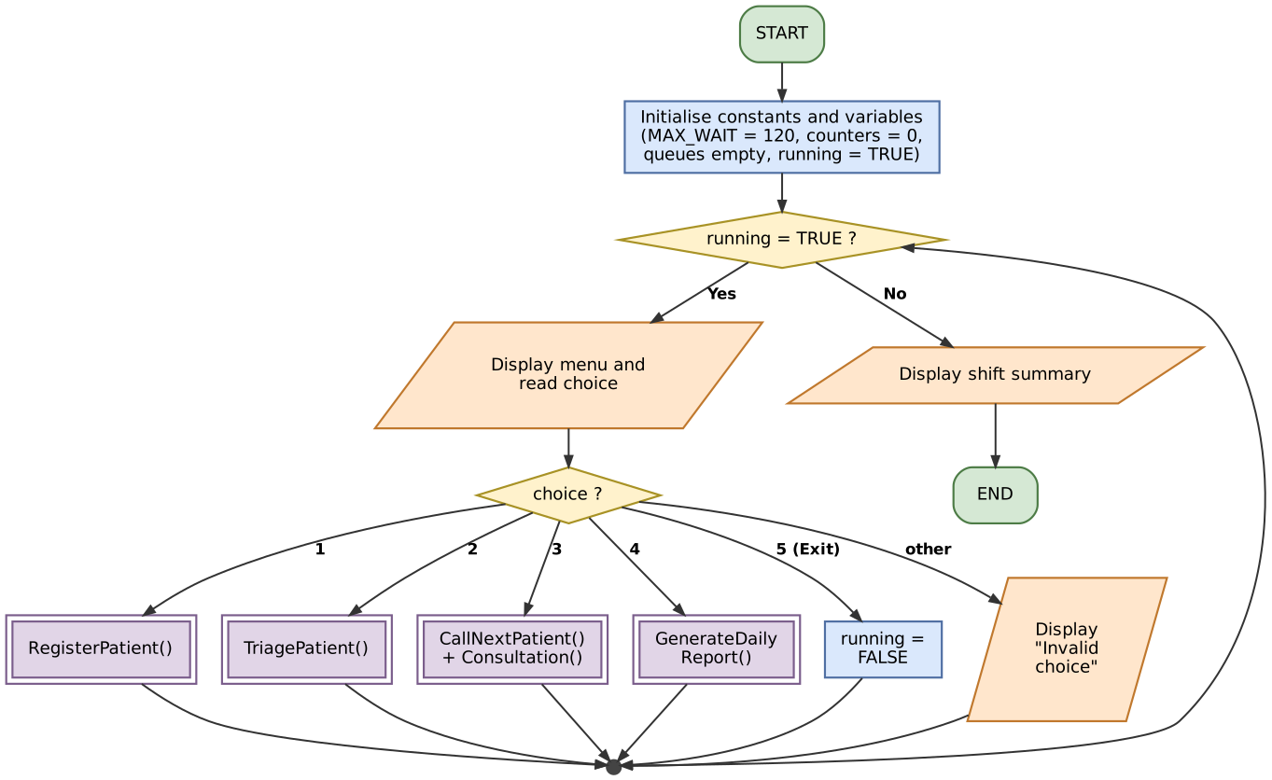
Figure 1: Main program flowchart (menu loop and module calls)

4.2 Registration Module Flowchart
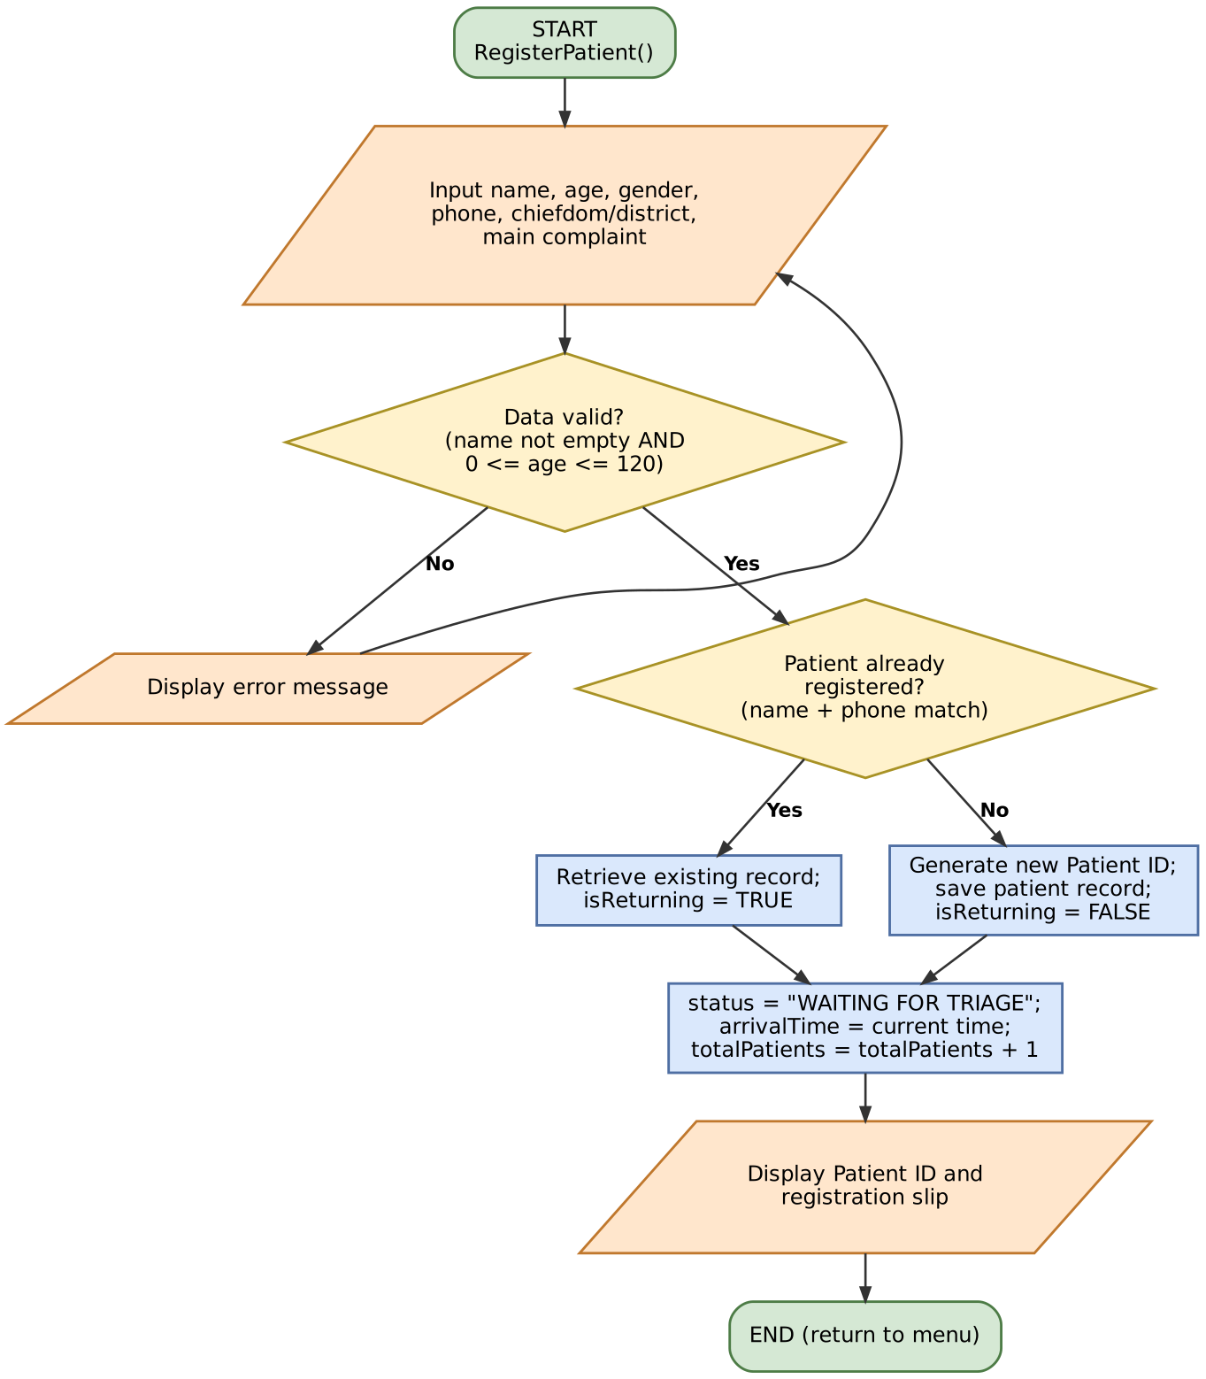
Figure 2: RegisterPatient module (input validation loop and returning-patient check)

4.3 Triage Module Flowchart
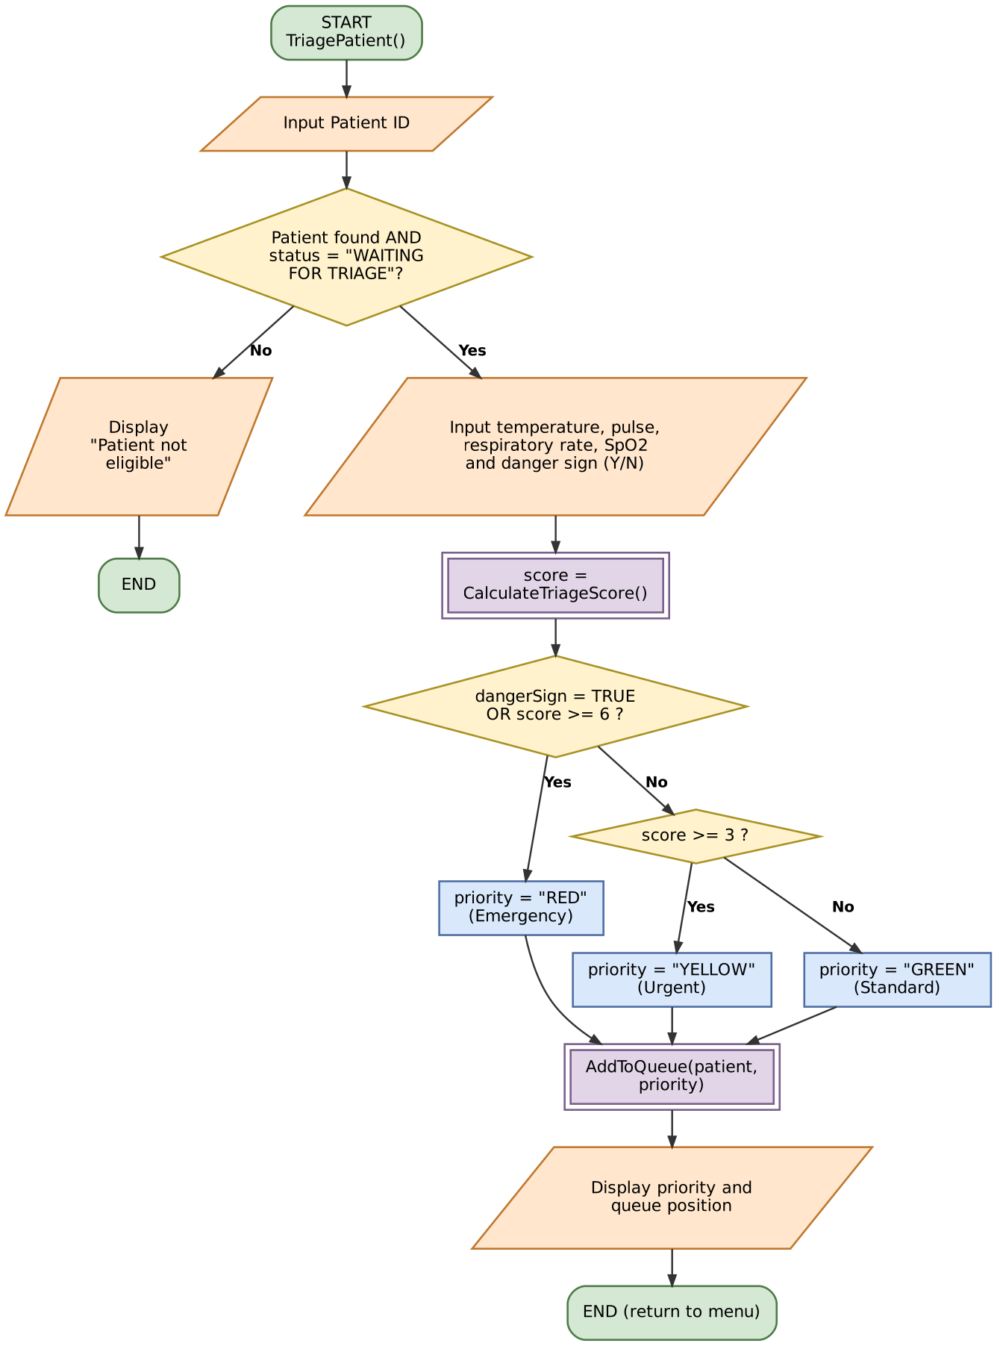
Figure 3: TriagePatient module (scoring and priority decisions)

4.4 Queue and Consultation Flowchart
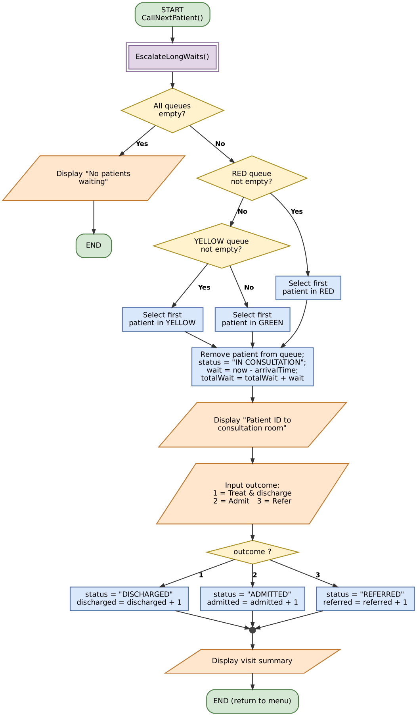
Figure 4: CallNextPatient and Consultation (RED, then YELLOW, then GREEN)

4.5 Long-Wait Escalation Flowchart
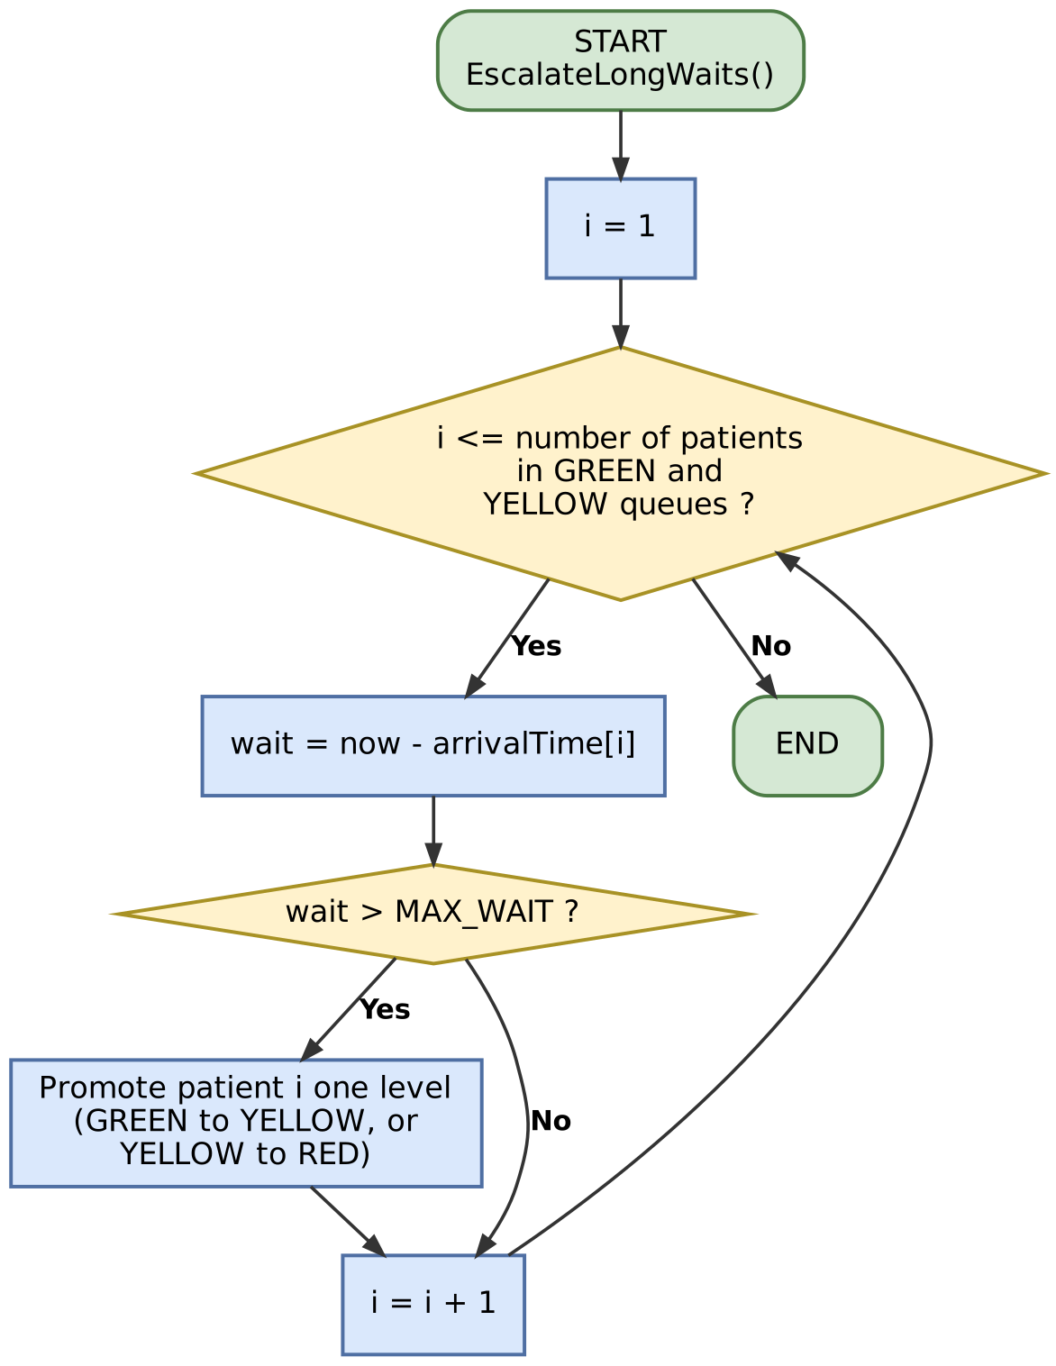
Figure 5: EscalateLongWaits (repetition structure)

5. Functional Modules
The solution is divided into small modules and functions. A module performs an action; a function returns one value.
Name | Type | Purpose | Parameters | Returns
Main | Module | Menu loop that controls the program | None | None
Initialize | Module | Sets counters to 0 and queues to empty | None | None
Register Patient | Module | Validates and records a patient | None (input read inside) | None
Triage Patient | Module | Scores a patient and queues them | None (input read inside) | None
Call Next Patient | Module | Selects the next patient by priority | None | None
Consultation | Module | Records discharge, admission or referral | p (Patient) | None
Escalate Long Waits | Module | Promotes patients waiting too long | None | None
Generate Daily Report | Module | Displays shift statistics | None | None
Read Integer | Function | Reads a whole number within a range | prompt, minValue, maxValue | Integer
Find Patient | Function | Finds a patient by name and phone | name, phone | Patient or EMPTY
Find By ID | Function | Finds a patient by ID | id | Patient or EMPTY
Calculate Triage Score | Function | Adds points from vital signs and age | temp, pulse, resp, spo2, age | Integer
Assign Priority | Function | Turns a score into RED, YELLOW or GREEN | score, dangerSign | String
Add To Queue | Function | Adds a patient to a queue | p, priority | Queue position (Integer)

Module structure:
Main
Initialise
RegisterPatient
FindPatient
TriagePatient
FindById, ReadInteger
CalculateTriageScore
AssignPriority
AddToQueue
CallNextPatient
EscalateLongWaits
Consultation
ReadInteger
GenerateDailyReport

6. Expected Outputs
Three sample patients arrive on the same morning. Times are minutes after the hospital opens at 08:00.

6.1 Sample Patients and Triage Results
Patient | Details and vital signs | Score workings | Result
HQ0001  Mohamed Sesay  Arrived: minute 0 | 28 years, male  Mild headache  Temp 37.2, pulse 78, resp 16, SpO2 98  Danger sign: No | All parameters 0  Score = 0 | GREEN  (score 0 to 2)
HQ0002  Aminata Conteh  Arrived: minute 20 | 67 years, female  Chest discomfort and weakness  Temp 37.8, pulse 112, resp 24, SpO2 92  Danger sign: No | Temp 0, pulse +1, resp +1, SpO2 +1, age +1  Score = 4 | YELLOW  (score 3 to 5)
HQ0003  Fatmata Kamara  Arrived: minute 35 | 3 years, female  Fever and convulsions  Temp 39.8, pulse 150, resp 34, SpO2 88  Danger sign: Yes | Temp +2, pulse +2, resp +2, SpO2 +3, age +1  Score = 10 | RED  (danger sign and score >= 6)

6.2 Sample Program Output
// Registration (in order of arrival)
Registration complete. Patient ID: HQ0001
Registration complete. Patient ID: HQ0002
Registration complete. Patient ID: HQ0003

// Triage (one queue position per line, in the same order)
Score: 0 Priority: GREEN Queue position: 1
Score: 4 Priority: YELLOW Queue position: 1
Score: 10 Priority: RED Queue position: 1

// Minute 45: first call (RED is served first although the others arrived earlier)
Call HQ0003 (RED) to the consultation room. Waited 10 min.
Outcome entered: 2
Visit summary: HQ0003 Fatmata Kamara - ADMITTED

// Minute 60: second call (YELLOW before GREEN)
Call HQ0002 (YELLOW) to the consultation room. Waited 40 min.
Outcome entered: 1
Visit summary: HQ0002 Aminata Conteh - DISCHARGED

// Minute 130: HQ0001 has waited more than 120 minutes, so he is promoted to YELLOW, then called
Call HQ0001 (YELLOW) to the consultation room. Waited 130 min.
Outcome entered: 1
Visit summary: HQ0001 Mohamed Sesay - DISCHARGED

Registered: 3 Seen: 3
Waiting - RED: 0 YELLOW: 0 GREEN: 0
Discharged: 2 Admitted: 1 Referred: 0
Average waiting time (minutes): 60
Average waiting time = (10 + 40 + 130) / 3 = 60 minutes.

6.3 Test Scenarios
No. | Test | Input | Expected output
1 | Valid registration | Name "Fatmata Kamara", age 3 | New Patient ID is displayed
2 | Invalid age | Age -4 | Error message, details requested again
3 | Empty name | Name left blank | Error message, details requested again
4 | Returning patient | Same name and phone as an existing record | Existing Patient ID is reused
5 | Unknown Patient ID | HQ9999 at triage | "Patient not found or not waiting for triage."
6 | Danger sign overrides score | Danger sign Y, all vital signs normal | Priority is RED
7 | Out-of-range vital sign | SpO2 = 150 | ReadInteger asks again (range 50 to 100)
8 | RED served first | RED, YELLOW and GREEN patients waiting | RED patient is called first
9 | Empty queues | Call next with nobody waiting | "No patients waiting."
10 | Invalid menu choice | Choice 9 | "Invalid choice. Please enter 1 to 5."

7. GitHub Evidence
Repository name, link, commit history and screenshots are to be completed from the student's own GitHub account. Placeholders are highlighted.
Item | Details
Repository name | PROG101Assignment Chernor Ibrahim Barrie 905006582
Repository URL | https://github.com/cleverboy- Chernor Ibrahim Barrie
Files uploaded | Report, flowcharts, pseudocode, README.md
License | MIT (code) and CC BY 4.0 (documents)

7.2 README.md and Repository Screenshots
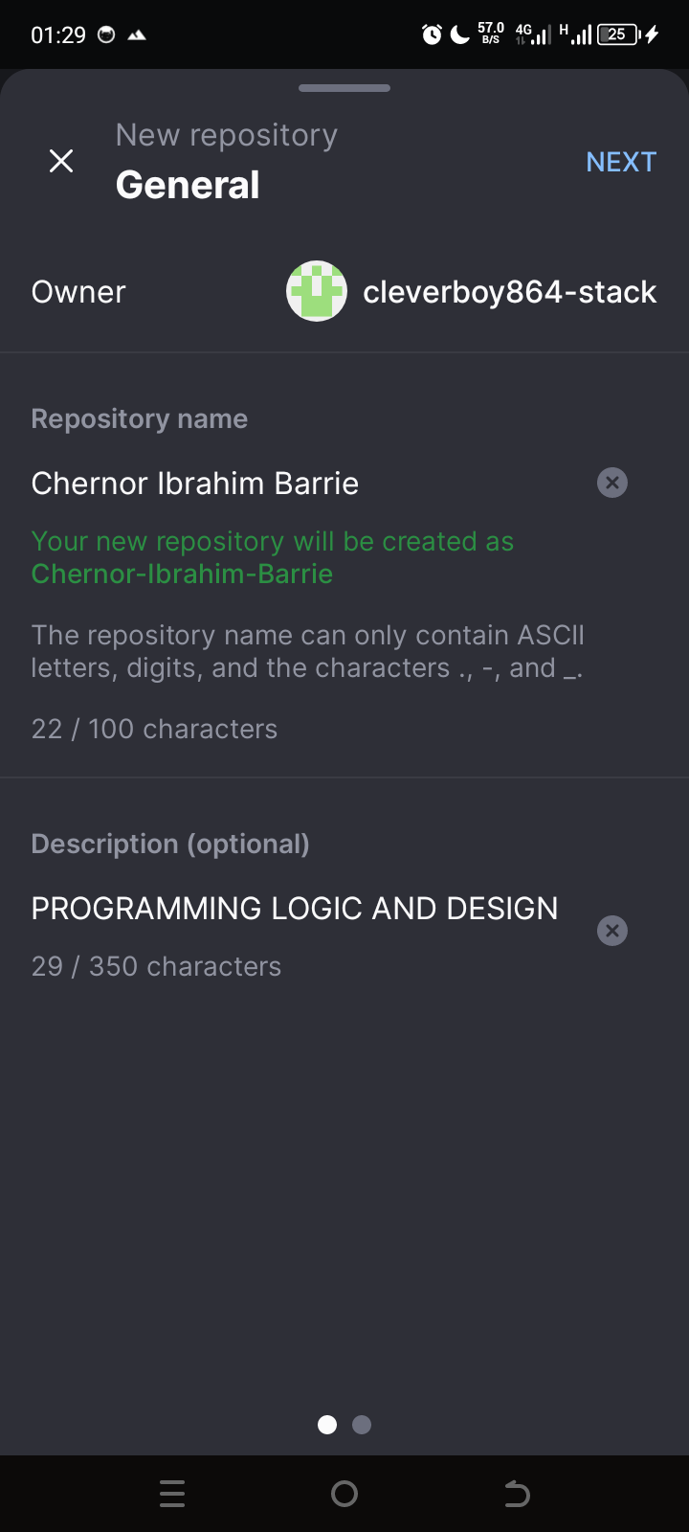

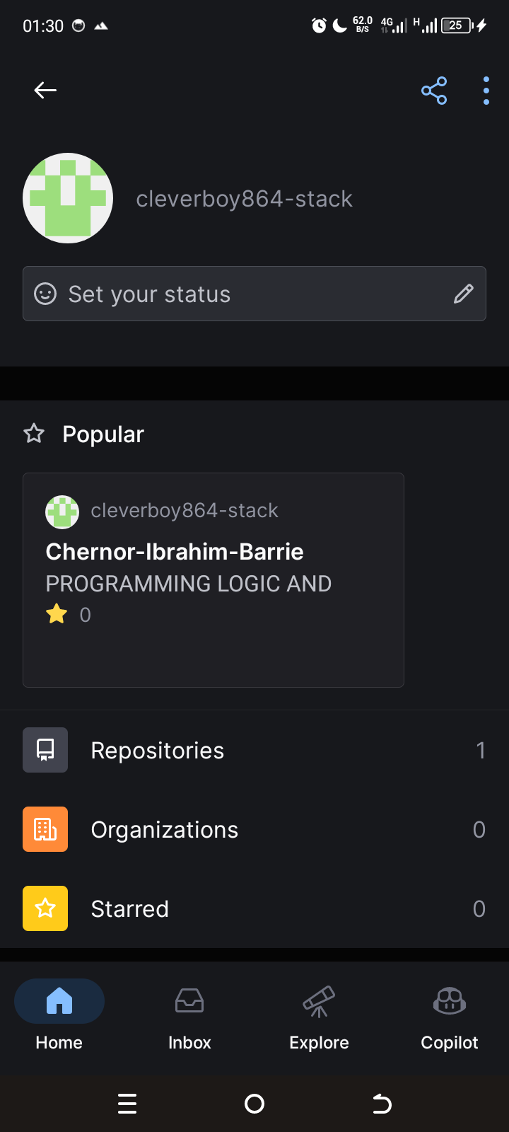

8. References
Chacon, S., & Straub, B. (2014). Pro Git (2nd ed.). Apress. https://git-scm.com/book
DHIS2. (n.d.). DHIS2: Health information management platform. University of Oslo. https://dhis2.org
Digital Public Goods Alliance. (n.d.). The Digital Public Goods Standard. https://digitalpublicgoods.net/standard/
Farrell, J. (2018). Programming logic and design, comprehensive (9th ed.). Cengage Learning.
Free health care for under-fives, expectant and recent mothers? Evaluating the impact of Sierra Leone's free health care initiative. (n.d.). https://www.ncbi.nlm.nih.gov/pmc/articles/PMC4877339/
Ministry of Health and Sanitation, Sierra Leone. (2018). National digital health strategy 2018 to 2023. https://extranet.who.int/countryplanningcycles/sites/default/files/public_file_rep/SLE_Sierra_Leone_National-Digital-Health-Strategy_2018-2023.pdf
Open Source Initiative. (n.d.). The open source definition. https://opensource.org/osd
OpenMRS. (n.d.). OpenMRS: Open source electronic medical record system. https://openmrs.org
United Nations. (2015). Transforming our world: The 2030 Agenda for Sustainable Development (A/RES/70/1). https://sdgs.un.org/2030agenda
Wing, J. M. (2006). Computational thinking. Communications of the ACM, 49(3), 33-35.
World Health Organization. (n.d.). National Health Workforce Accounts: Sierra Leone. https://apps.who.int/nhwaportal/Sown/Files?lang=EN&name=SLE
World Health Organization. (2016). Updated guideline: Paediatric emergency triage, assessment and treatment. WHO.

